COMPUTER ARCHITECTUTRTE
CSA1214 CO4-AT1
T.Brijesh(192521391)

1. A mobile device manufacturer observes noticeable lag when users switch rapidly between multiple applications. Analyze how L1, L2, and L3 caches and DRAM participate in storing and retrieving frequently accessed application data. Based on latency, capacity, hit rate, and bandwidth requirements, propose a suitable hierarchical memory
Anwser :
1. Memory Hierarchy
A mobile processor uses different levels of memory. Smaller memory is faster, while larger memory is slower.
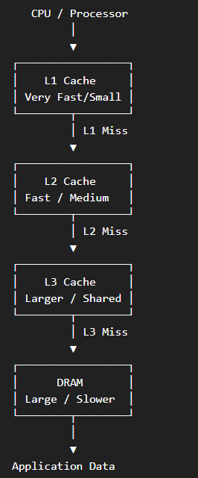

2. How Application Switching Works
When a user quickly changes from one application to another, the processor needs to retrieve the application's instructions and data.
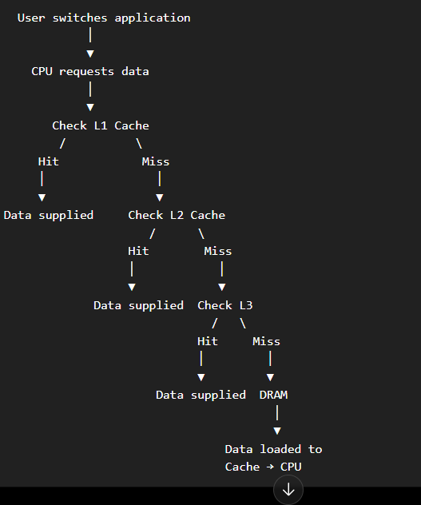
3. Role of Each Memory
L1 Cache
- Closest to the CPU.
- Very fast but very small.
- Stores the most frequently used instructions and data.
- Gives the fastest response.
L2 Cache
- Larger than L1 but slightly slower.
- Stores data that is not found in L1.
- Helps reduce accesses to slower memory.
L3 Cache
- Larger than L2 and usually shared among CPU cores.
- Useful when multiple applications are running.
- Keeps frequently used application data available during application switching.
DRAM
- Much larger than cache.
- Stores active applications and their data.
- Has higher latency than caches.
- Frequent DRAM access can cause noticeable lag.
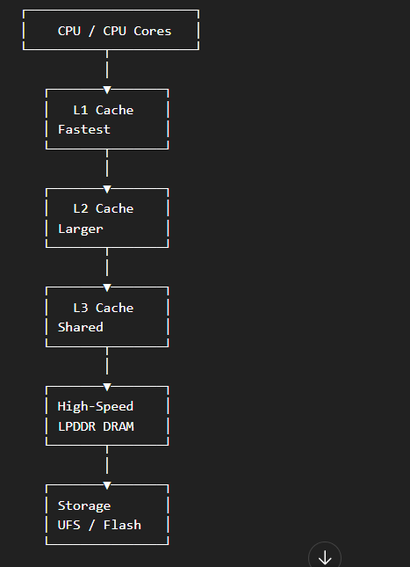
Final Analysis
The main reason for application-switching lag is cache misses that force the processor to access DRAM. A good hierarchy should therefore provide:
Small, extremely fast L1 → larger L2 → large shared L3 → high-capacity, high-bandwidth DRAM.
This combination gives low latency, high cache hit rates, sufficient capacity, and high bandwidth, making application switching faster and smoother.
2. A cloud service provider experiences increased latency when processing database queries from a large number of concurrent users. Analyze how cache hierarchy and virtual memory paging influence memory access performance, and compare their roles in reducing processor-memory latency. Recommend suitable memory technologies and memory-management improvements that can minimize page faults, reduce access delays, and improve database throughput.
Anwser:
A cloud database may have thousands of users accessing data simultaneously. The processor needs to retrieve database instructions and data quickly.
The cache hierarchy reduces processor-memory latency, while virtual memory provides a larger logical memory space.
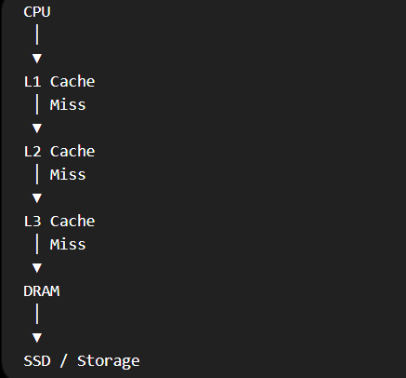
Cache hierarchy
Frequently accessed database data is kept in cache.
For example:
- Frequently used database indexes
- Query instructions
- Frequently accessed records
- Database metadata
If the data is found in cache, access is very fast.
If it is not found, the processor goes to DRAM.
Virtual memory
Virtual memory allows programs to use a logical address space larger than physical RAM.
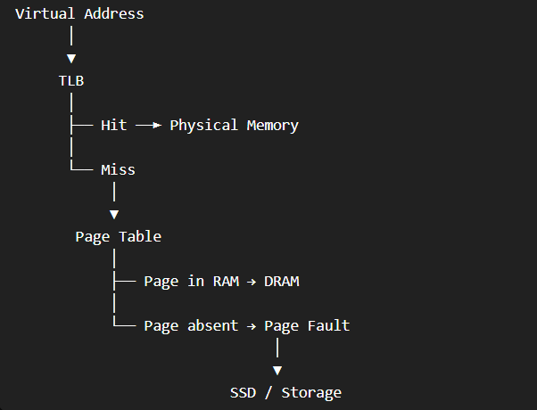
Page fault:
A page fault occurs when the required page is not present in physical memory.
The operating system must retrieve it from storage.
This is much slower than accessing DRAM.
How to reduce page faults
- Increase available DRAM.
- Keep frequently accessed database pages in RAM.
- Use efficient page-replacement algorithms.
- Use large/huge pages.
- Use TLBs to speed address translation.
- Use fast SSDs when storage access is necessary.
Result
Good cache management + sufficient DRAM + fewer page faults =
Lower latency + faster database queries + higher throughput.
3.An autonomous vehicle continuously receives large volumes of sensor data from cameras, LiDAR, radar, and other real-time sensing systems. Evaluate the characteristics of SRAM, DRAM, and MRAM in terms of access latency, bandwidth, capacity, volatility, and power consumption. Based on the real-time processing requirements, design an appropriate memory hierarchy that can provide high-data-transfer bandwidth while minimizing access latency and supporting reliable sensor-data processing.
Anwser:
An autonomous vehicle receives huge amounts of data from:
- Cameras
- LiDAR
- Radar
- GPS
- Other sensors
This data must be processed very quickly because decisions such as braking and steering can be time-critical.
SRAM is used for very fast, latency-critical data.
For example:
- Sensor processing
- CPU/NPU cache
- Real-time control calculations
DRAM provides much larger capacity.
It can store:
- Camera frames
- LiDAR point clouds
- Radar data
MRAM is non-volatile, meaning it retains data even when power is removed.
It can be used for:
- Important configuration data
- Frequently accessed persistent information
- Fast-startup information
Suitable hierarchy

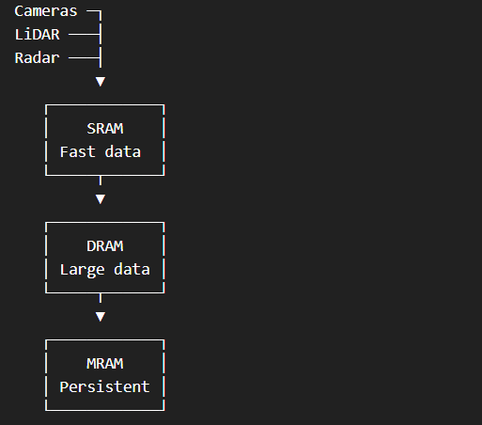
Result:
SRAM provides low latency, DRAM provides high capacity and bandwidth, and MRAM provides fast non-volatile storage.

4. An edge-based AI device must load machine-learning models quickly while operating under strict power and storage constraints. Analyze the characteristics of NAND Flash, DRAM, and SRAM with respect to access speed, storage capacity, persistence, power consumption, and suitability for AI workloads. Recommend a hierarchical memory organization that enables fast model loading, efficient immediate-data processing, reduced energy consumption, and improved overall inference performance.
Anwser :
An edge-AI device must execute AI models locally instead of always sending data to the cloud.
Examples include:
- Smart cameras
- Drones
- Robots
- Industrial controllers
- Mobile AI devices
NAND Flash stores the AI model permanently.
For example:
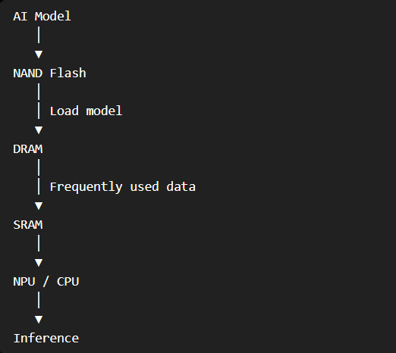
DRAM
DRAM stores:
- Loaded AI models
- Model weights
- Intermediate activations
- Input data
It provides much higher capacity than SRAM.
SRAM
SRAM stores the most frequently required data.
It is useful for:
- Frequently accessed weights
- Intermediate calculations
- CPU/NPU cache
Improvements
AI performance can be improved using:
- Quantization – represent weights using fewer bits.
- Compression – reduce model size.
- Prefetching – load data before it is required.
- DMA – transfer data efficiently without excessive CPU involvement.
- Larger SRAM/cache for frequently accessed data.
Result:
NAND Flash → permanent model storage
DRAM → model execution
SRAM → ultra-fast processing
This gives fast model loading, lower power consumption, and better inference performance.
5. A high-performance gaming console experiences frame drops and noticeable delays when loading large game environments containing high-resolution textures, audio, and other assets. Analyze the interaction between L3 cache and DRAM during the retrieval and processing of frequently accessed game data, considering their latency, capacity, and bandwidth. Propose suitable memory-hierarchy enhancements that can reduce data-access bottlenecks, increase memory throughput, and provide smooth frame rendering during large scene transitions.
Anwser:
Modern games contain very large amounts of data:
- High-resolution textures
- 3D models
- Audio
- Physics data
- Game instructions
- Shaders
The CPU and GPU need this data quickly to maintain a high frame rate.
Memory hierarchy
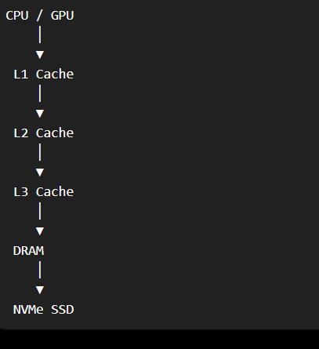Cache
L3 is larger than L1 and L2.
It can hold frequently accessed game data.
If the CPU finds the required data in L3:
L3 hit → Fast access
If it is not there:
L3 miss → DRAM access
DRAM
DRAM has much larger capacity and can hold the active game environment.
It stores:
- Textures
- Audio
- Geometry
- Game state
- Frame-buffer-related data
- AI data
Why frame drops occur
Suppose the game suddenly needs a large texture.
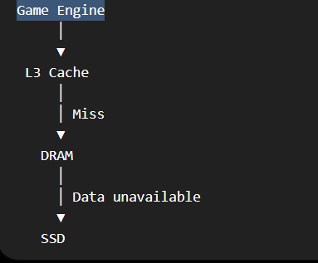
If the required data takes too long to arrive, the CPU/GPU may not receive it in time for the next frame.
This can cause:
Data-access delay → rendering delay → frame drop/stuttering
Solutions
- Increase L3 cache capacity.
- Use high-bandwidth DRAM.
- Use prefetching.
- Stream assets from SSD before they are needed.
- Use DMA for fast data transfer.
- Compress textures and game assets.
- Keep frequently accessed data in cache.
Result
A good hierarchy provides:
Large L3 cache → fewer DRAM accesses → high-bandwidth DRAM → faster asset processing → smoother frame rendering.

